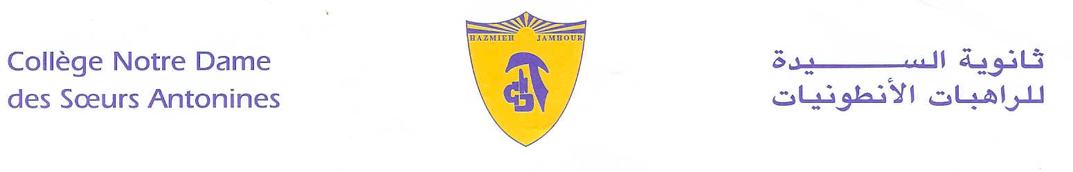
Book List
2019-2020

Grade 3
- Reading- Journeys book- Houghton Mifflin- Harcourt- Volume 3.
- Workshop- Sadlier Oxford- Level Green.
- Spelling Connections- 4- Zaner- Bloser-2016.
- Listen, Please! Level three - world Heritage Publishers. (available at school)
- Mathematics- Macmillan- Pupil’s book- 3A- 3B
- Science- Macmillan- Pupil’s book -3 + workbook-3- + CD- (David and Penny Glover)
- Coccinelle- Livre Français- CE2- Hatier +Cahier d’Activités-Programmes 2016.
- Vivre le Français- cahier d’écriture- EB3- Hachette- Antoine.
- Dictionnaire Fr/Fr- Le Robert- Sored.
- Right Click Grade 3 – 2016 – Linfopourtous.
- ProtectEd- Student workbook- Level 3.

- لغتي فرحي- في القراءة- السنة الثالثة الساسية- سمر القاضي- دار الفكر اللبناني.
- البشرى السارة : الرب يسوع حياتي- السنة الثالثة الأساسية- منشورات حبّة الحنطة.

Remark:
We would like you to pay at the Antonine Sisters School-Jamhour the fees for stationary and for cultural activities (obligatory, cf.Cir053/19), and buy the school uniform starting from Monday 9 till Friday 13 September 2019 from 8:30 a.m. till 13:30 p.m.
English, Math and science books are available at school.

Hazmieh, Place Mar Tacla - Tel +961 5 45 32 33 / 45 32 34 - Cell +961 3 60 04 37 - Fax +961 5 45 77 99
Jamhour, Rue EDL - Tel +961 5 76 90 27 / 76 90 28 - Cell +961 3 69 86 08 - Fax +961 5 76 84 15
B.P. 45 201 Hazmieh, Liban - www.antonines-hazmieh.edu.lb - info@antonines-hazmieh.edu.lb

