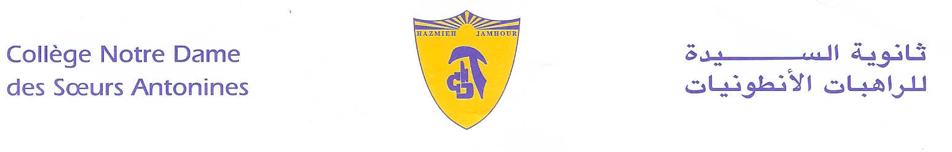
Book List
2019-2020
KG3
- Reading Journeys volume 1.2
- Spelling Connections -1-2016.
- Tommy Math- Volume 1- Volume 2- (KGII)- (Jean Boustany- Antoine Sayegh)- Samir éd.- 1st ed. 2004.
- I play and I discover- KGII- Sami Khoury- Marcelle Allam Zakaria- Ed.2010- vol 1
- Le jardin enchanté- 12ème- Edition Hachette + cahier d’activités 1-2.
- ProtectEd- Student workbook – KG2.

- لغتي فرحي ((1-2-3 + لواصق تعليميّة- الروضة الثالثة (التمهيدي)- دار الفكر اللبناني.
- التمهيد للّقاء بالرب يسوع- الصف الثاني عشر- منشورات حبة الحنطة.

Remark:
We would like you to pay at the Antonine Sisters School-Jamhour the fees for stationary and for cultural activities (obligatory, cf.Cir053/19), and buy the school uniform starting from Monday 9 till Friday 13 September 2019 from 8:30 a.m. till 13:30 p.m.
English books are available at school.

Hazmieh, Place Mar Tacla - Tel +961 5 45 32 33 / 45 32 34 - Cell +961 3 60 04 37 - Fax +961 5 45 77 99
Jamhour, Rue EDL - Tel +961 5 76 90 27 / 76 90 28 - Cell +961 3 69 86 08 - Fax +961 5 76 84 15
B.P. 45 201 Hazmieh, Liban - www.antonines-hazmieh.edu.lb - info@antonines-hazmieh.edu.lb

